Instructions: Analyze the following crime scene. Support your stance through argument and evidence.

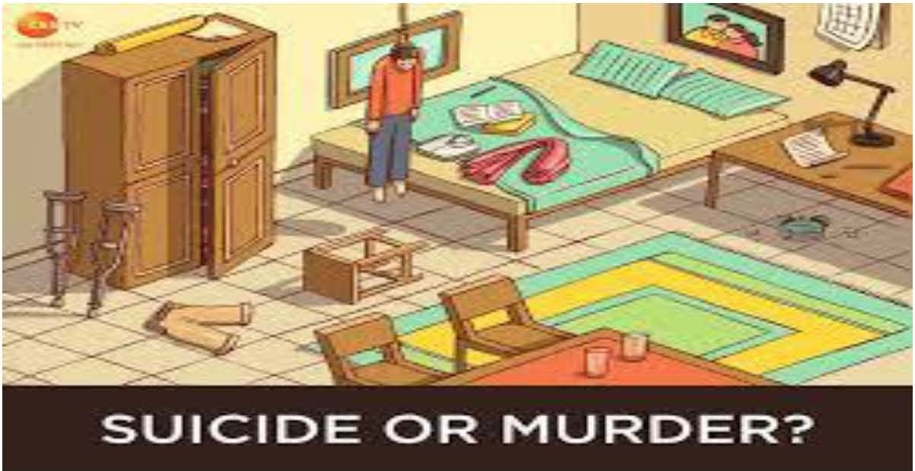

As far as I've seen things, it's a **murder** to me because there are a lot of indications which supports my stance.

* The clock is broken down which indicates that the victim tried to save himself from the killer so due to

the fight between them the clock broken down.

* There are two water glasses in the room which clearly indicates that there were two persons not a

single one. And the victim knew the other person very well.

* There are 2 crutches in the room and they are very far from the victim which shows that the victim was a

disabled man. So how a disabled person stands on stool without the crutches which are away from him.

* There is a book with a pen on the bed which shows that the victim was reading/writing and also there is a

page and pen on the table to which it turns out that someone was writing on page from the pen surely a

Suicide note which seems to be planted to show the victim suicide.

so from all of the indications and evidences in my opinion it is a **murder** not a suicide.